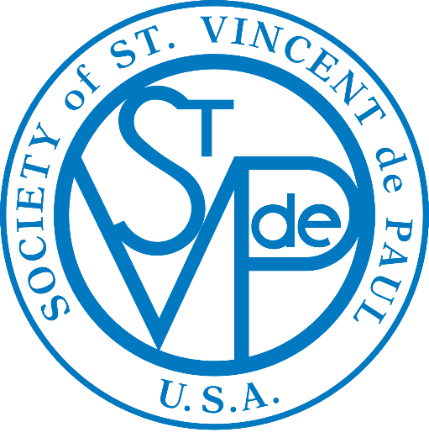
WEEKLY BULLETIN ANNOUNCEMENTS
Liturgical Year B

1st Quarter
April—May—June 2024

The “Weekly Bulletin Announcements”, based on the Gospel of each Sunday, are suggested for your parish weekly bulletin.

The action statement can easily be adapted to fit your local needs.

This is a very effective way for the Society of St. Vincent de Paul to encourage all the members in the parish:
- To have ears to hear the “cries of the poor,”
- To have eyes to “seek and find the forgotten, the suffering or the deprived,” and
- To have hearts that “bring God’s love to the poor” through their generosity and donations.

It is also very effective to use personal stories about who you have served (not using names) and how you have been able to help them.

April 7 - Second Sunday of Easter:
In the Gospel today, Jesus stands in the midst of us and says: “Peace be with you!”
During Mass we turn to each other and say “Peace be with you!” As you put your gift into the St. Vincent de Paul box you say “Peace be with you!” to those who are poor and hungry.

April 14 - Third Sunday of Easter:
In this Sunday’s Gospel, Jesus explains that the meaning of the scriptures. Like the disciples, when we offer and receive forgiveness our hearts burn because we encounter the risen Christ within us.
Have you considered answering the call to “help the poor find forgiveness and healing in their life” by joining the Society of St. Vincent de Paul?
April 21 - Fourth Sunday of Easter:
Today, we celebrate “Good Shepherd Sunday” where we reflect on Jesus’care and love of us.
This month, through your gifts, the Society of
St. Vincent de Paul brought the love and care of Jesus to the poor by assisting ___________families, providing________ in food, ___________for utility and rent bills, etc. Thank You!

April 28 - Fifth Sunday of Easter
In the Gospel today, Jesus says “Whoever remains in me and I in him will bear much fruit, because without me you can do nothing.” Indeed, by helping the poor we can “bear much fruit” and we find that with Jesus we can do everything.
Your gift to the Society of St. Vincent de Paul will show that you are indeed the disciple of Jesus as it will bring your love to those who live in fear and doubt, loneliness and dread.
May 5 - Sixth Sunday of Easter:
In the Gospel today, Jesus says to us, “This is my commandment: love one another as I have loved you…You are my friends if you do what I command you.”
By your gift to the Society of St.Vincent de Paul you fulfill this commandment.

May 12 - The Ascension of the Lord:
Today as we celebrate the feast of the Ascension we are reminded that Christ’s saving work on earth continues through his disciples…and now through us.
When we give to the poor, God indeed pours his love, peace and joy into our hearts, into our lives and into the hearts of those who are poor.
May 19 - Pentecost:
Today as we celebrate Pentecost the Holy Spirit wants to make us advocates of God’s presence to bring new life to others, especially those who do not know the love of God in their lives.
This month, through your gifts, the Society of St. Vincent de Paul was able bring the love of God to the poor by assisting _______families, providing_____ in food,_______for utility and rent bills, etc. Thank You!

May 26 - Most Holy Trinity:
As we celebrate the mystery of the Trinity we also realize the mystery of how much God loves and cares for us each day. Believing in this our lives can then overflow in thanksgiving and praise.
Your gift in the St. Vincent de Paul Poor Box will help the poor to believe in the mystery of God’s love for them.

June 2 - Corpus Christi:
Today as we celebrate the gift of the Body and Blood of Christ let us pray for those who are hungry, malnourished and starving.

Is there a family you know who needs assistance? Please call the Society of St. Vincent de Paul so that together we can help those who are hungry.

June 9 - Tenth Sunday of Ordinary Time:
Today, Jesus looking around those seated in the circle said, “Here are my mother and my brothers. For whoever does the will of God is my brother and sister and mother.”
Through your almsgiving you are indeed doing the will of God and your gift placed in the St. Vincent de Paul poor box indeed brings Christ’s love and compassion to the poor.

June 16 - Eleventh Sunday of Ordinary Time:
In the Gospel, Jesus says: “This is how it is with the reign of God. A man scatters seed on the ground. He goes to bed and gets up day after day. Through it all the seed sprouts and grows without his knowing how it happens.”
Through your almsgiving you are sowing seeds that grow far greater than you know. The coins placed in the St. Vincent de Paul Poor Box bring Christ love and compassion to the poor.

June 23 - Twelfth Sunday of Ordinary Time:
In the Gospel today, Jesus calms the sea and then asks the disciples “Why are you lacking in faith.” In our life’s journey, we also must learn to believe in God’s presence and to trust in his care.
This month, through your gifts, the Society of St. Vincent de Paul was able to continue show God’s love and care to others by assisting _____families, providing_____ in food, ______in gifts, and ______for utility and rent bills.

June 30 - Thirteenth Sunday in Ordinary Time:

In today’s Gospel we see how in faith, Jarius asked Jesus to heal his daughter and how Jesus then answered his prayer. In prayer we also come to know that we are loved by God, and in that trust we ask for healing for ourselves, our loved ones and all those who are suffering.
This week, please join with the Society of St. Vincent de Paul in praying for the healing of all those who are ill and especially those who have no one to pray for them.

