**Vincentian Awareness Month**

# Society of St. Vincent de Paul

## Milwaukee Archdiocesan Council

### 2024

Conference Guide

|  |  |
| --- | --- |
| **Greetings!** Vincentian Awareness Month has traditionally provided us the opportunity to share our story of service to Neighbors in Need in our communities. We encourage parish members to put their faith into action when we share the story of the Society of St. Vincent de Paul. Awareness Month begins in celebration of the Feast Day of St. Vincent de Paul, (September 27) and resources are provided for publication in October.  The weekly topics are Spirituality, Friendship, Service, Servant Leadership and Solidarity with the Poor. This guide provides suggestions for publicity, promotion, and conference prayers or activities. Share information with the parish pastor or director, secretary or media and bulletin editors. The images and websites can be used in online platforms for social media, parish websites, as well as bulletins. New this year is a toolkit offered by the National Office for membership marketing, [“See the Face of Christ. Be the Face of Christ”](https://members.ssvpusa.org/news/see-the-face-of-christ/).  Share Your Story of Vincentian Life  with Others! | **Image of Frederic Ozanam on a home visit in the Mouffetard district of Paris.**  A painting of a person with a child  Description automatically generated  Information compiled by the Milwaukee District Council Staff and reviewed by the Archdiocesan Council Voice for the Poor Committee. |

# **Theme: Spirituality**

## **Prayers for Conference Meetings**

### *A Prayer to Ignite the Fire of Our Vincentian Hearts*

O God, you provide us with your Holy Spirit as light to guide us on our life’s journey and to guide the Saint Vincent de Paul Society just as you gave your Spirit to the Apostles on Pentecost Sunday. As we recognize that light as an ember in our hearts, help us to fan that flame to be a beacon of hope to the path of our needy brothers and sisters and to revitalize our society.

We ask for your wisdom, strength, and courage to open our mind and heart as you did to the founders of our society. Help us to renew our conferences through the insight and ideas shared during this month of Vincentian Awareness. We also ask you to open the hearts of people to consider this ministry as a way to manifest their faith by service to others.

Help all of us to see where transformation in our own lives can bring us closer to You. Help us to know that growth occurs through transformation and a willingness to accept new challenges, ideas, and opportunities as we thank you for calling us to the gift of this ministry.

We ask this through Christ our Lord, our healer and source of all hope. Amen

*By Deacon Paul Klingseisen, Milwaukee Council*

***For More Information:*** [***VisionSVdP Resources***](https://ssvpusa.org/vision-svdp-resources/)

# Vincentian Commitment Ceremony at Mass

Provide this guide to the presider as a way to profess your Vincentian commitment. Suggestion is to rise from your seat and stand in your pew at the appointed time during Mass. Make copies of the guide for Vincentians in attendance so that they can read aloud their response.

 Presider: I invite the members of our parish who represent us as members of the St. Vincent de Paul Society to stand to profess their Vincentian Commitment to serve the poor on behalf of our parish. Spirit of the living God,

**Vincentians:** **Come and breathe your life anew.**

Presider: Passionate fire of God’s love,

Vincentians: **Ignite the talents and gifts of everyone present here and enkindle our hearts with the fire of your love.**

 Presider: Do you commit yourself to spiritual growth in your work, so that you may bear witness to the love of God and to see the face of Christ in the faces of those you serve?

**Vincentians:** **We do.**

 Presider: Do you commit yourself to serve the poor in a spirit of justice and charity?

**Vincentians:** **We do.**

 Presider: We ask the Lord to bless you: (sign of blessing)

May the flame of God’s love light your way and lead you to grow in the path of spirituality and holiness.

**Vincentians: Amen**

 Presider: May the Spirit strengthen you in the ways of justice and charity, and may you bring hope and healing into the hearts of all those who are poor and suffering.

**Vincentians:** **Amen**

 Presider: May your hands and hearts be nourished for the work that lies ahead, that you may be compassionate to human need, tender and strong in your care and faithful to the commitment of service you renew today.

**Vincentians: Amen**

Be seated after the commitment ceremony and blessing.

# Commitment Ceremony During a Conference Meeting

If you are unable to gather during Mass, use this guide during a conference meeting to celebrate your spirit of friendship and commitment to Vincentian service.

President or Spiritual Advisor: I invite you to join me in professing our commitment to serve the poor on behalf of our parish. In response to the call of Christ who invites you to follow him, do you promise to be a witness to his boundless love for the poor, the lonely, the suffering and deprived, those without faith and those who feel unloved?

**Vincentians: I do, and I ask for the grace to grow in holiness of life and to share in a longing for spiritual growth and enrichment.**

President or Spiritual Advisor: Do you firmly resolve to treasure the warm friendship and unity which was, from the beginning, a hallmark of our Society?

**Vincentians: I do, and I ask for the grace to grow in humility and simplicity so that true friendship may grow in my heart.**

President or Spiritual Advisor: Do you promise to seek and find the forgotten, the suffering or the deprived so that you can bring them your love?

**Vincentians: I do, and I ask for the grace to be sensitive to their vulnerability, to respect and not to judge or blame them.**

President or Spiritual Advisor: Do you promise to be generous with your time, your possessions and yourself in your mission of charity?

**Vincentians: I do, and I ask for the grace to always serve in justice and charity so that I can be an advocate and a voice for the poor.**

President or Spiritual Advisor: Do you promise to persevere in regarding your home visits as a sacred trust?

**Vincentians: I do, and I ask for the grace to be more aware of the blessings I receive from those I visit.**

President or Spiritual Advisor: Let us pray together:

**Vincentians: Lord Jesus, you who willed to become poor, give us eyes and hearts directed toward the poor. Help us to recognize you in them—in their hunger and thirst, their loneliness and suffering. Enkindle within us the fire of love that burned in the hearts of St. Vincent de Paul and Blessed Frédéric Ozanam, so that we will live our mission and core values with integrity. Grant us the grace to be faithful to the Society of St. Vincent de Paul, so that we will grow in spirituality, friendship and service with and to our suffering brothers and sisters. Amen.**

## Conference Action Steps- Spirituality

* **Ask the pastor or parish director** to inform parishioners of Vincentian work. Provide an impact message about the importance of the gift certificates, food baskets, or holiday collections you provide. If possible, tell a short story of a special home, hospital, or nursing home visit. Sharing a personal story (keeping confidentiality in mind) is one of the most effective tools that we have for motivating parishioners or community members to act.
* **Use the newly updated resource, *Creating a Culture of Welcome***, as a guide to conduct a membership drive. This resource provided by the National Office was previously known as Invitation to Serve.

[**Creating a Culture of Welcome - EN**](https://parishgear.com/collections/the-society-of-saint-vincent-de-paul/products/creating-a-culture-of-welcome)[**Crear Una Cultura de Bienvenida - ES**](https://parishgear.com/collections/the-society-of-saint-vincent-de-paul/products/crear-cultura-de-beinvenida-packet)

* **Attend Mass** on the Feast Day of (or on the Sunday closest to) St. Vincent de Paul together as a conference. The feast day is on September 27th.
* **Reflect and pray together** using the Formation Resources provided by Tim Williams, SVDP-USA Senior Director, Formation & Leadership Development.
  + [**Fred Talks on Vimeo**](https://vimeo.com/showcase/6978890)
  + [**Reflections**](https://members.ssvpusa.org/formation/formation-resources/vincentian-reflections/) **for Conference meetings (EN and ES)**
  + [**Contemplations**](https://members.ssvpusa.org/formation/formation-resources/contemplations/) **for individuals**

**Mosaic of Blessed Frederic Ozanam 
Basilica of the National Shrine of the Immaculate Conception, Washington, DC- 2020**

[**Mosaic of Blessed Frédéric Ozanam**](https://famvin.org/en/2020/01/11/blessed-frederic-ozanam-to-be-honored-at-u-s-national-basilica/)

Basilica of the National Shrine of the Immaculate Conception, Washington, DC- 2020

# **Bulletin Articles**

## Week 1 – Spirituality

On September 27, we celebrate the feast of St. Vincent de Paul, a priest during the 17th Century known as the "Great Apostle of Charity” and recognized for his great compassion, humility, and generosity. The St. Vincent de Paul Society was established in Paris, in 1833, and has been present in the United States for over 175 years. The Society is represented in the parishes of the Milwaukee Archdiocese with over 120 conferences.

Members of the Society of St. Vincent de Paul are called Vincentians. They journey together in friendship to put their faith into action by offering service to people experiencing poverty, suffering and need.

Today begins our Awareness series to inspire you to learn more about the Society’s history and mission. Vincentian members of our parish ask for your prayers to encourage them in their mission of following Christ through compassionate service to those in need.

You can find more information about the National Society of St. Vincent de Paul at [www.svdpusa.org](http://www.svdpusa.org). Our local website is (Enter your own district or local website address, if applicable).

## Week 2 – Friendship

*“It is our vocation to set people’s hearts ablaze, to do what the Son of God did, who came to light a fire on earth in order to set it ablaze with His love.”* Bl. Frédéric Ozanam

Vincentians are guided by three essential elements:

* SPIRITUALITY
* FRIENDSHIP
* SERVICE.

The practice of a faithful life, guided by prayer and devotion to Mass, is the foundation. In the spirit of friendship, Vincentians meet regularly to pray and reflect on the Gospels. Enriched by the Word, they are inspired to encounter Christ in service to the poor, lonely, needy, disheartened, or ill.

The home visit is the basic, most fundamental activity of a Vincentian ministry. Rather than have people come to us, we make friendly visits to them. When we are able, we try to meet the immediate need first and then try to help them develop a longer-term plan. One of our most important gifts to leave behind is a feeling that someone cares and that there is hope. In times of social distancing, Vincentians adapted their means of outreach and were able to provide the compassionate care of Christ in a changing environment. Now, we need your hands to help in outreach to those in great need. Would you like to learn more about the St. Vincent de Paul conference of our parish? Contact: (insert local conference contact information).

## Videos and Social Media

*Serve your neighbor. Make new friends. Grow in your faith.* Video links for the “See the Face of Christ. Be the Face of Christ” membership campaign are encouraging and insightful. Share these on your parish website and social media platforms.

Learn More! [**Volunteer with St. Vincent de Paul**](https://catholic.lpages.co/face-of-christ/)

# **Theme - Friendship**

## Conference Action Steps- Friendship

* **Each one Reach one:** Each member makes a commitment to invite a friend, relative or parishioner to one of the Society activities - serving at a meal program, helping at the pantry, or attending a conference meeting.
* **Offer to host** a Donut/Coffee Sunday after Masses.Display information about your conference activities. Distribute prayer cards, bookmarks, flyers to those who stop by. Invite them to a meeting, ask them to assist with a special collection, introduce them to others in your conference.
* **Commit to participate**, together, as friends of your conference. Make a goal to review and renew your Conference Standards of Excellence. Participate in the SVdP Vision listening sessions because Your Voice Matters. Re-energize your membership recruitment efforts. Look over the *See the Face of Christ. Be the Face of Christ* membership materials and set a goal to attract 2 members with these new resources at your fingertips.
  + [**Standards of Excellence**](https://svdpmilw.org/uploads/Minimum%20Requirments%20for%20Traditional%20Conferences%20List.pdf)
  + [**Vision SVdP Resources**](https://ssvpusa.org/vision-svdp-resources/)
  + [**Vision SVdP Online Submission**](https://ssvpusa.org/vision-svdp-online/)
  + [**SVDP-USA Membership Marketing Campaign**](https://members.ssvpusa.org/news/see-the-face-of-christ/)
    - [**Digital Downloads**](https://parishgear.com/collections/the-society-of-saint-vincent-de-paul/products/crear-cultura-de-beinvenida-packet) (scroll past merchandise for free downloads)

# **Theme – Service**

The feast of Blessed Frédéric Ozanam (1813-1853), the founder of the Society of St. Vincent de Paul, is on September 9. As a college student in 1833, Frédéric led a small group of his classmates into the poor areas of Paris to do what they could to address their needs for food and fuel. Blessed Sr. Rosalie Rendu (1786-1856) taught them how to minister to God’s poor. Working one-to-one with families, they gave witness to non-believers about the vitality of their faith. This model of assistance spread through Europe and arrived in our Milwaukee Archdiocese in 1849. Frédéric and friends took St. Vincent de Paul (1581-1660), whose feast day is on September 27, as their patron saint.

## Conference Action Steps- Stores

Thrift stores are a special ministry of SVDP. There are 18 St. Vincent de Paul Thrift Stores in our Archdiocese. In addition to household necessities to persons served by over 100 SVDP conferences, the stores produce surplus income to support the other activities and programs in their local counties, such as meal programs, food pantries, and other special works to help families and individuals in need.

* **Host an ’awareness table’** at your Council thrift store. Have information available about all SVDP does in your local community. Promote with flyers and signage throughout the thrift store. Have store specials available to encourage new shoppers.
* **Make copies and display** the SVDP [**Thrift Stores- Southeast Wisconsin**](https://svdpmilw.org/uploads/SVDP%20Stores%20SE%20WI%202024%20Flyer.pdf) flyer.

## Conference Action Steps- Meal Sites & Food Pantries

SVDP conferences sponsor and support various meal sites or food pantries throughout the Archdiocese to provide nutritious meals or food choices to families and individuals in need. Volunteers are critical to their success.

* **Invite others** to volunteer with your conference members at one of the SVDP Society meal sites. Volunteer help is always appreciated, and you’ll be rewarded by the smiles on the faces of those you serve.
* **Hold a drive to collect items** needed for the meal sites for seasonal events such as Back to School, Easter baskets, or special occasions. Talk with the meal site coordinators to determine what items are needed.
* **Hold an Open House** to showcase your food pantry operation. Give tours to show what food is available, what is needed, and how it’s organized. Hold a *Spring* *Cleaning* event, so parishioners can help you clean shelves and reorganize!
* **Hold a drive to collect items** needed at your Food Pantry. Toiletries, paper products or laundry products are needed as well as food items.

### **Bulletin Graphics**

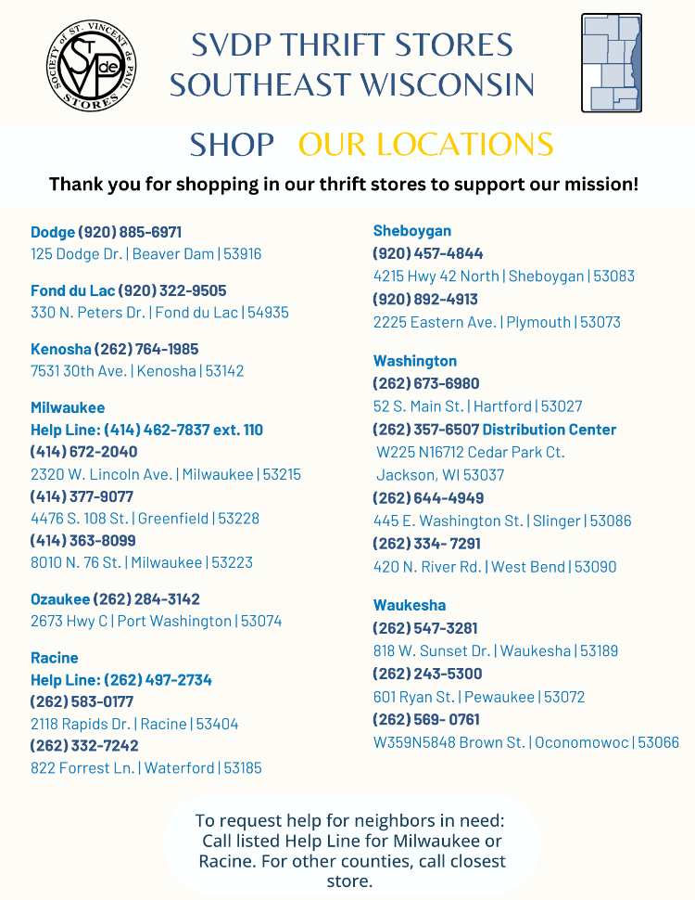

# **Bulletin Articles**

## Week 3 – Service

Members of the St. Vincent de Paul Society visit people in all kinds of distress to offer a helping hand and a listening ear. Aside from helping with basic needs for the homes of individuals and families, Vincentians provide for the unhoused, the homebound, and the imprisoned. Two-person teams conduct needs assessments. Personal visits are the catalyst of our worldwide organization.

Service in the spirit of St. Vincent de Paul can be appealing to any age group. “No act of service is foreign to the society.” Families can serve together at meal sites or food pantries. ‘Mini-Vinnies’ are groups of young people that come together for fundraisers or service projects. Working adults assist with data entry, social media posts, and other tasks that fit in busy schedules. Retirees provide services that can fill free time during the day. Do you, a friend, a grandchild, or neighbor have the ability or gift to share? Do you feel a nudge to assist in this long-standing lay ministry? For information on how easy it is to get involved, contact (enter local conference contact information).

**Statistical Data:** Share the Good News of your charitable works and gratitude for monetary donations and support by sharing statistical data with your parish members.

#### **For Example- Conference Level**

* # of Visits
* # of children / adults helped
* Type of assistance provided
* Financial details
* # of years your conference has been active in the parish
* # of members and total years of service

#### **For Example- Council Level**

* # of conferences in your council
* # of visits overall
* Fiscal year monetary donations or donated goods
* # of Vincentians overall
* # of service hours overall
* # of people whose needs were met by council conferences

### **Safeguarding**

The Milwaukee Archdiocesan Council of the St. Vincent de Paul Society implemented a Safeguarding Policy in 2023 which requires all members and volunteers who interact with vulnerable persons to complete a Safe Environment Certification. Account set-up/access for back ground check authorization, training module completion and acceptance of Safeguarding Policy can be located at <https://svdpmilw.cmgconnect.org>.

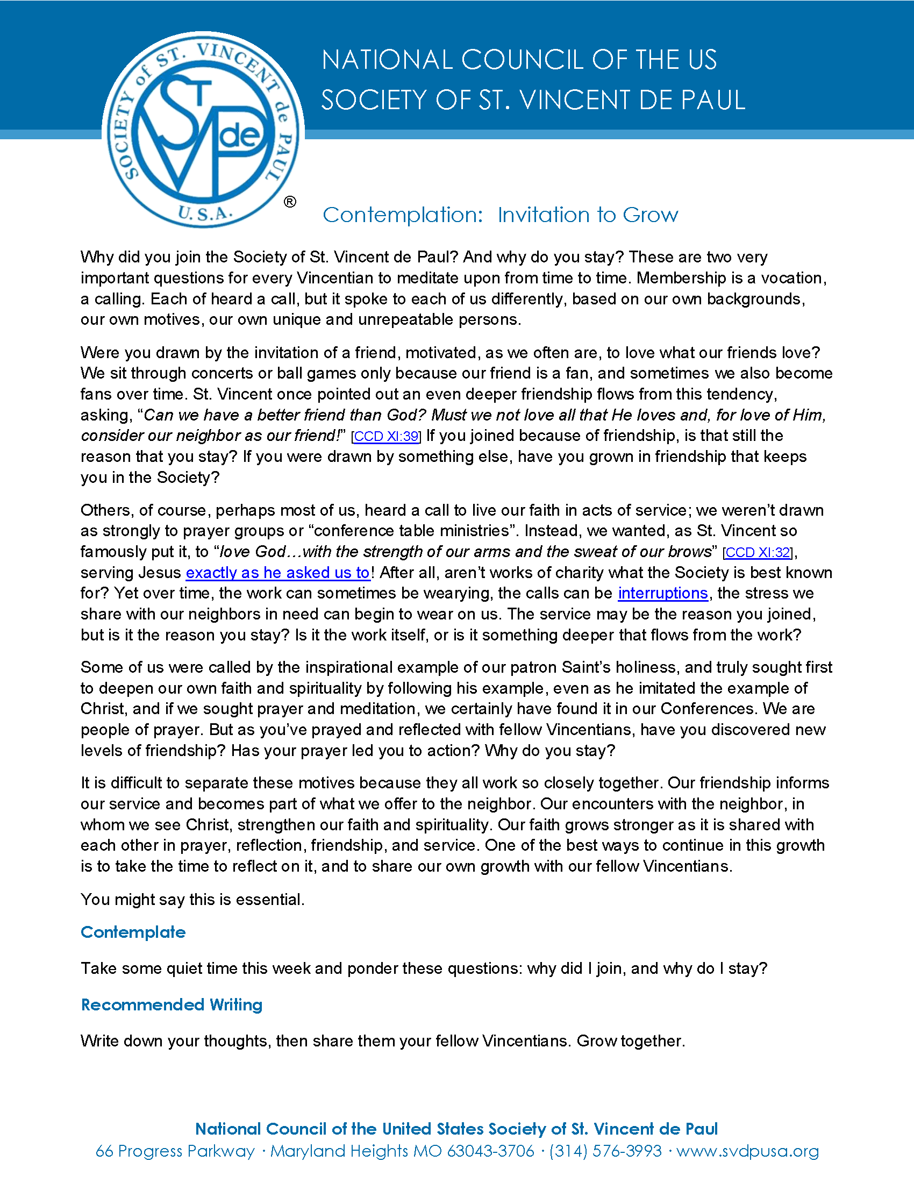

# **Theme- Servant Leadership**

A servant leader’s life is based on spirituality, friendship, and service. “St. Vincent de Paul had a profound impact during his lifetime. He transformed the way social service was practiced in Europe…He did this through strategy and action, as leader and manager. His legacy is carried on today in organizations he organized, nurtured, and inspired – the Congregation of the Mission, Daughters of Charity, Ladies of Charity, the St. Vincent de Paul Society, and others” (Vincentian Leadership Model, depaul.edu). Following the example of Jesus, Vincent invited ordinary people to join in extraordinary service. He looked for and encouraged the goodness of people’s hearts. Thus inspired, Vincentians are rooted in looking for new and better ways to serve those in need.

## Conference Action Steps- Servant Leadership

* **Update Conference Leader Contact Information**: This is a good time of year to inform your Pastor or Parish Director of any changes in leadership for your conference. Provide a list of the names of your Conference Officers and Spiritual Advisor. Invite your parish leaders to a “meet and greet’ conference meeting to pray together, to offer your assistance and answer questions.
* **Servant Leadership Prayers**: Pray for Vincentian leaders as a conference by using this booklet: [**Vincentian Servant Leader Prayers**](http://svdpmilw.org/uploads/Vincentian%20Pathway%20-%20Servant%20Leadership%20Prayers.pdf).
* **Walking the Vincentian Pathway**: This is a process of ongoing formation for Vincentians as you discover, develop, and deepen your Vincentian heart and discern the many opportunities for Vincentian leadership. More information can be found here: <https://members.ssvpusa.org/formation/vincentian-pathway-toolbox/>
* **Invitation For Renewal:** This is a Vincentian Servant Leadership Formation Program for current and emerging Vincentian Leaders. Participants learn to move forward in ways that are true to both our spiritual foundation and the needs of those who are living in poverty today. Contact Sherry Brown for information at  [sbrown@svdpusa.org](mailto:)  or 314-576-3993 ext. 200.
* **SVDP-USA Youth:** Post the information in the links below in your parish social media platforms or bulletin and invite young adults to join you in a service activity or a conference meeting. More information at: <https://members.ssvpusa.org/youth-young-adult/>
  + [**SVDP Young Adult Information Flyer**](https://svdpmilw.org/uploads/SVdP-Young-Adults-Information-Flyer.pdf)
  + [**SVDP High School Service Hours Flyer**](https://svdpmilw.org/uploads/Youth-High-School-Flyer.pdf)

# **Bulletin Articles**

## Week 4- Servant Leadership

A Vincentian heart is a heart on fire to serve the mission of Christ. A ‘super volunteer’ of his time, Frédéric Ozanam’s vison was “to establish a network of charity and social justice to circle the world.” We are deeply grateful for the St. Vincent de Paul conference members at our parish who readily show Christ’s love to people experiencing poverty, suffering and need. In the aftermath of the COVID-19 crisis, they reliably moved into action to relieve distress in our community. They bring hope to situations that seem impossible, and they remain faithful to their purpose because they see the face of Christ in others. Ask yourself: Do I feel a nudge to assist in this long-standing lay ministry? In this time of great need, has my heart been moved to help relieve distress in my community? We invite you to follow your heart and serve with us.

Learn more about the Vincentian impact by contacting: (enter local conference contact information).

**Weekly Bulletin Announcements:** SVDP Society provides a quarterly resource of short bulletin reflections on the weekly readings. Access the quarterly announcements at the link below**:**

[**Bulletin Announcements Quarterly Resource – EN and ES**](https://members.ssvpusa.org/formation/formation-resources/bulletin-announcements/)

## Week 5- Solidarity with the Poor

Besides offering direct service to individuals and families, the St. Vincent de Paul Society (SVDP) maintains a standing committee—the Voice for the Poor Committee—to inform Catholics on legislative issues affecting the lives of the poor.

From time to time, this committee broadcasts **Action Alerts**regarding issues before state or federal legislatures. SVDP members and parishioners are urged to contact their elected representatives to support or oppose legislation affecting the poor.

You can stay informed on these important issues by registering to receive Action Alerts from [**VoterVoice**](https://votervoice.net/SVDPUSA/home).

Consider joining the Voice for the Poor Committee in your area. The Milwaukee Archdiocesan Council VOP Committee meets virtually each month to discuss timely issues and topics that impact those in need locally and welcomes new members.

For more information, you can contact the VFP Committee Chairperson: [**dabusch99@yahoo.com**](mailto:dabusch99@yahoo.com)

# **Theme- Solidarity with the Poor**

In addition to quietly and discreetly serving families and individuals in need in our Archdiocese, Vincentians also are concerned over the broader issues that affect them. The St. Vincent de Paul Society has a standing committee called the Voice for the Poor with the purpose to educate its members on legislative issues that impact the lives of the poor. Vincentians are urged to identify these negative impacts and share their concerns with those who legislate and administer programs to lessen the suffering of the poor. Some Vincentians also become mentors to people who are having difficulty in managing things in their lives. Waukesha County SVDP, for example, runs a “Coming Together to Get Ahead” program, which helps people change their lives.

### Conference Action Steps-Solidarity with the Poor

* **Sign up for** [**VoterVoice**](https://votervoice.net/svdpusa/home). At times, the Voice for the Poor Committee may issue [***Action Alerts***](https://votervoice.net/SVDPUSA/home)to make Vincentians aware of issues that affect the poor which are before State or Federal legislative bodies. Make sure your conference discusses these alerts. Members of the Society are urged to contact their respective legislators to support or oppose such legislation which affects the poor.

The primary information sources on most issues are the National SVDP Voice for the Poor Committee, Catholic Charities U.S.A., the United States Conference of Catholic Bishops, and the Wisconsin Catholic Conference.

* **Join the VFP Committee**. The Voice for the Poor speaks as a unified voice on behalf of the poor. The Archdiocesan Voice for the Poor Committee meets on the second Saturday of each month. Contact Dave Busch, VFP Committee Chairperson, for more information: [dabusch99@yahoo.com](mailto:dabusch99@yahoo.com).
* **Read the minutes** of the Voice for the Poor Committee meetings to learn more about the sub-committee reports on the topics of Energy, Criminal Justice, Housing, Hunger/FoodShare, Human Trafficking, Immigration, Mental Health Care, and Minimum Wage/Labor. Minutes are posted on the Milwaukee Council website: <https://svdpmilw.org/vincentians-vicentinos.aspx>

## Video Introduction: Voice for the Poor

](https://vimeo.com/928491977)

[**https://vimeo.com/928491977**](https://vimeo.com/928491977)

Link: [**Thank You Fill-In Blanks Flyer**](https://svdpmilw.org/uploads/Awareness%20Month%20Thank%20You.pdf)

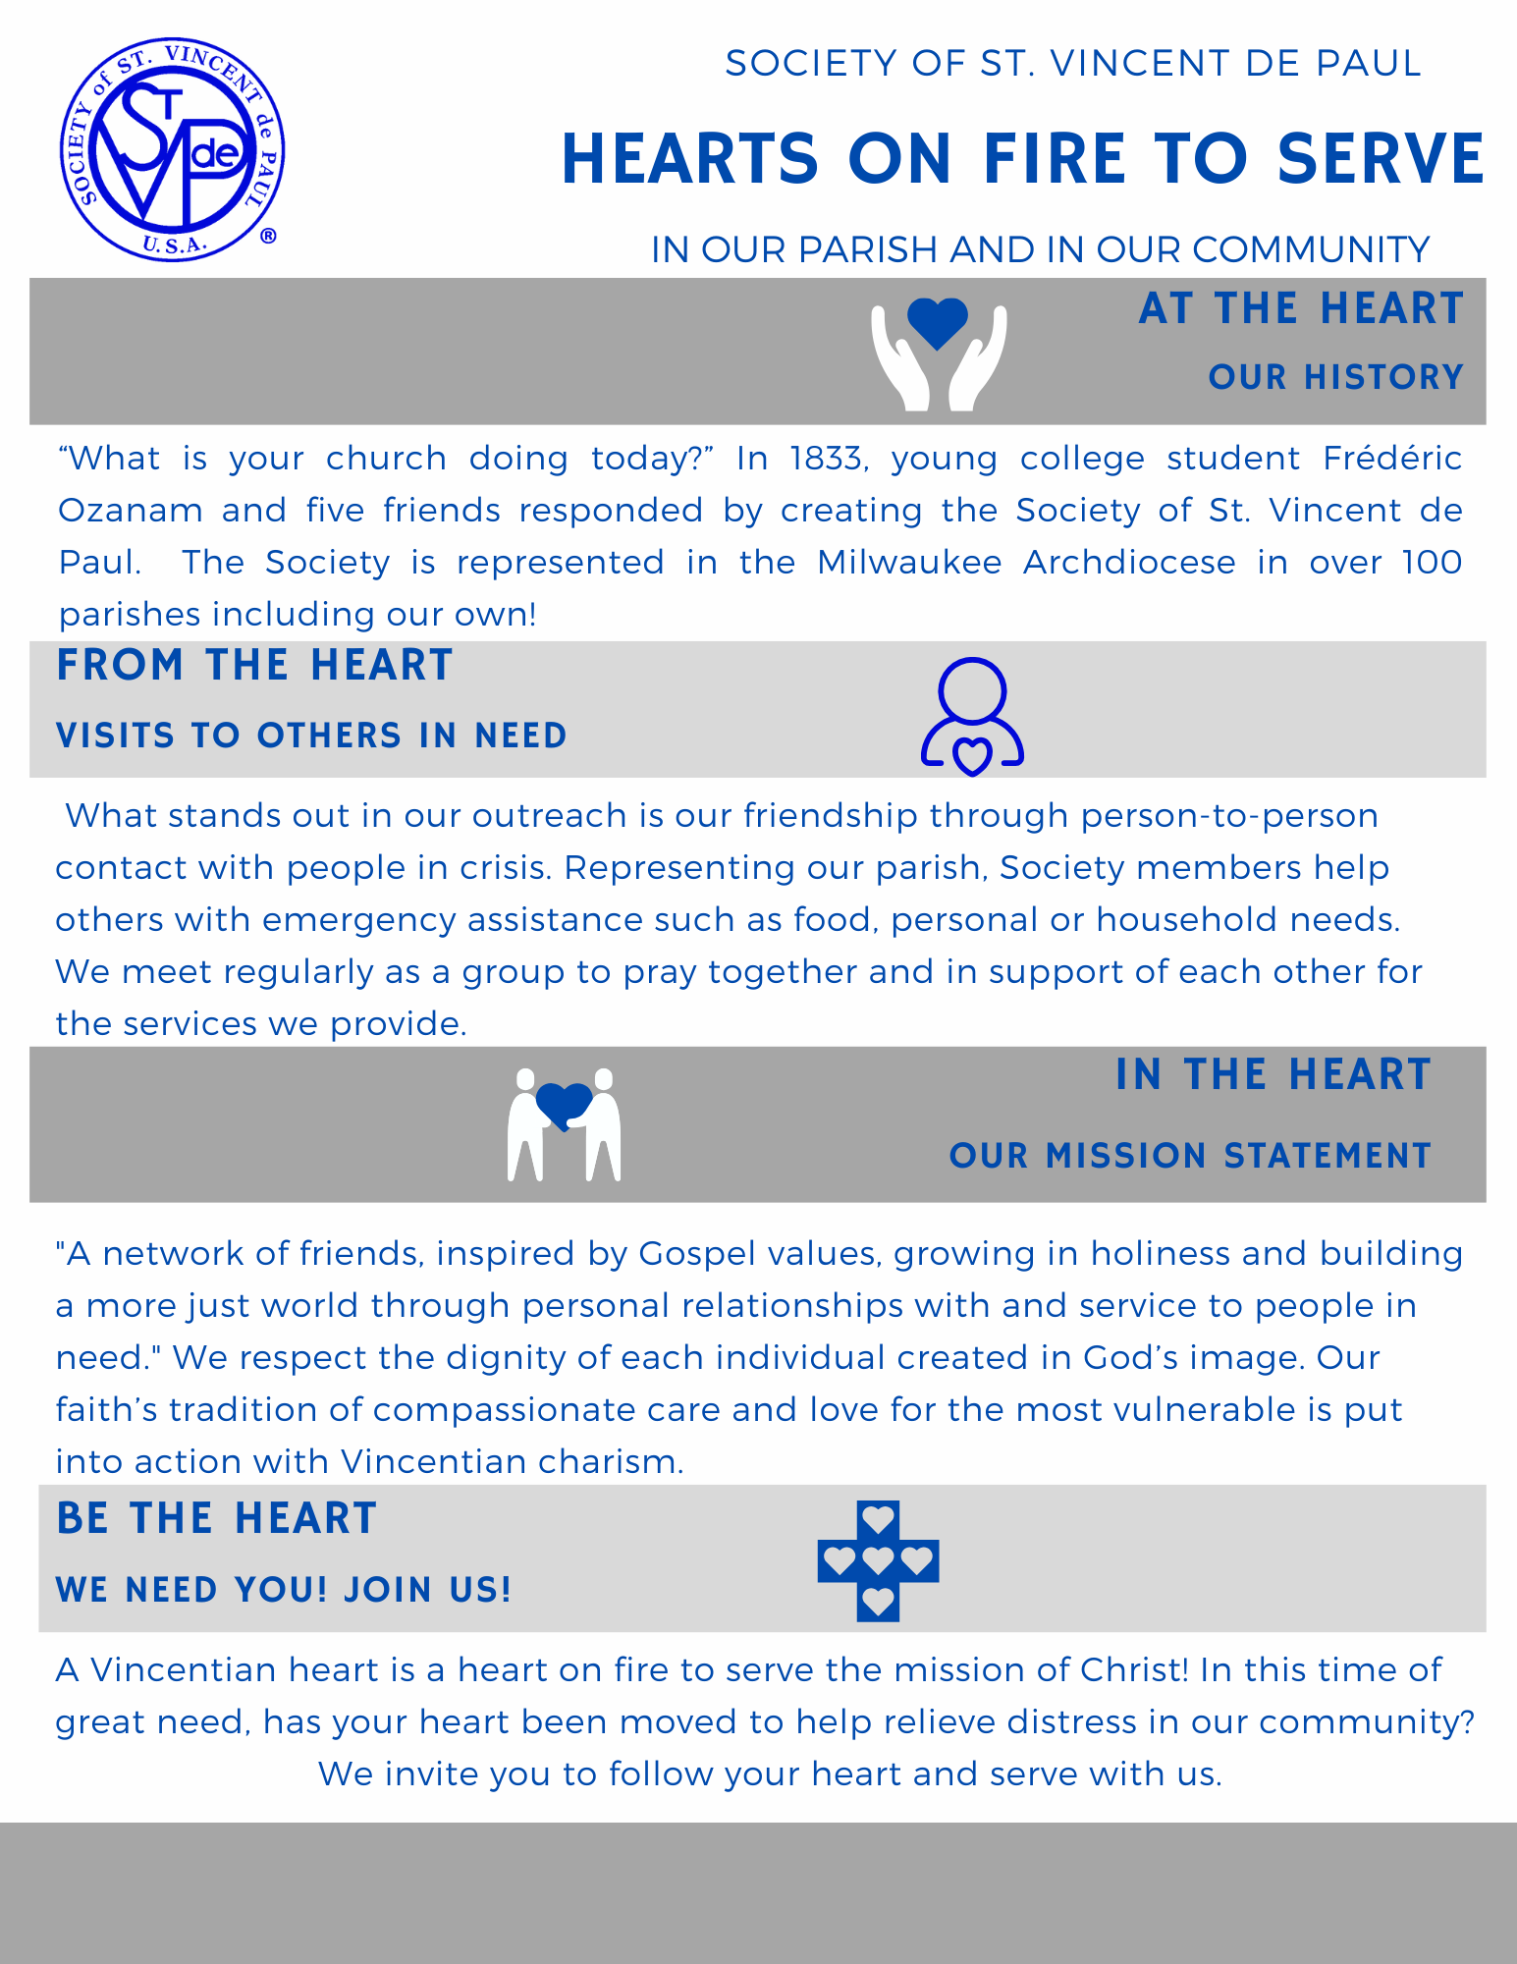

**Links:** [**Hearts to Serve Flyer**](https://svdpmilw.org/uploads/Hearts%20to%20Serve%20Flyer%202024-ARCH.pdf) **|** [**Face of Christ Flyer 8.5X11**](https://svdpmilw.org/uploads/campaign%20flyer%201.0c%20bleeds.pdf) **|** [**Face of Christ Sign 11x17**](https://svdpmilw.org/uploads/campaign%20sign%201.0a%20bleeds.pdf)