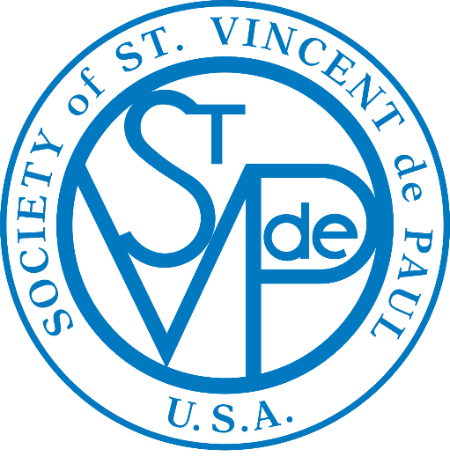
WEEKLY BULLETIN ANNOUNCEMENTS
Liturgical Year B

3rd quarter
July—August—September 2024

The “Weekly Bulletin Announcements”, based on the Gospel of each Sunday, are suggested for your parish weekly bulletin.

The action statement can easily be adapted to fit your local needs.

This is a very effective way for the Society of St. Vincent de Paul to encourage all the members in the parish:
- To have ears to hear the “cries of the poor,”
- To have eyes to “seek and find the forgotten, the suffering or the deprived,” and
- To have hearts that “bring God’s love to the poor” through their generosity and donations.

It is also very effective to use personal stories about who you have served (not using names) and how you have been able to help them.

July 7 - Fourteenth Sunday in Ordinary Time:
In today’s Gospel the people ask : “How is it such miraculous deeds are accomplished by his hands?” Because of your gift to the Society of St. Vincent de Paul many “miraculous deeds” are accomplished for the poor.
This week put a gift in the St. Vincent de Paul poor box, knowing that through your kindness someone who is suffering will be touched by God in a miraculous way.

July 14 - Fifteenth Sunday in Ordinary Time:
In the Gospel today we see how Jesus sent his Apostles out two by two. From the beginning of the Society of St. Vincent de Paul, members visit in pairs “two by two”, those who are poor and needy in their homes. It is there, in the family setting, that Vincentians listen, offer humble advice, and render assistance.
Have you considered answering the call to help serve the poor by joining the Society of St. Vincent de Paul?

July 21 - Sixteenth Sunday in Ordinary Time:
In this Sunday’s Gospel, Jesus tells his disciples to “Come away by yourselves to a deserted place and rest a while.” Vincent de Paul, a great man of action was also a contemplative. His contemplation of God’s love overflowed into practical love for the poor.
Please say a special prayer for the poor and forgotten, as you place your gift in the Society of St. Vincent de Paul poor box.

July 28 - Seventeenth Sunday in Ordinary Time:
In the Gospel, Jesus supersedes both the apostles’ and the crowds’ expectations: with little he feeds many…Jesus is the sign of God’s lavish presence and love. Your donation to the Society of St. Vincent de Paul is indeed a sign of God’s extravagant love to the lonely and the poor.
This month, through your gifts, the Society of St. Vincent de Paul was able to assist families, providing in food, for utility, rent and other bills. God Bless You!

August 4 - Eighteenth Sunday in Ordinary Time:
The Gospel tells us “This is my beloved Son. Listen to him.” By “listening” we are able to live the gospel. Gospel living is something so simple as taking the time to listen to those who need to spill out their hearts when seeking help.
Through your gift to the Society of St. Vincent de Paul you enable the members of the Society to become a “listening heart” to the hungry, the homeless and the struggling poor.

August 11 - Nineteenth Sunday in Ordinary Time:
In this Gospel the love that Jesus reveals through the symbol of the cross is: self-giving, sacrificial, healing, forgiving, in solidarity with the weak, confident in the power of God.
During the hot summer months many of the elderly, especially those who are sick, are not able to find relief from the heat. Please help the Society of St. Vincent de Paul to bring respite and hope to them.

August 15 – The Assumption of the Blessed Virgin Mary:
In today’s Gospel, even the child in Elizabeth’s womb leaps with joy at the approach of Mary, the “lowly servant,” who by accepting God’s plan for her became blessed for all generations.
With love for your neighbors who have nothing, look around your house to see what furniture, household items, and clothing you no longer use…and give it to the Society of St. Vincent de Paul.

August 18 - Twentieth Sunday in Ordinary Time:
In today’s Gospel, Jesus tells us that “Whoever eats my flesh and drinks my blood remains in me and I in him.” As we know, our loving God cannot be seen by our eyes, but only experienced through loving people.
With love for your neighbors who have nothing, look around your house to see what furniture, household items, and clothing you no longer use…and give it to the Society of St. Vincent de Paul.

August 25 - Twenty-First Sunday in Ordinary Time:
In today’s Gospel, Jesus asks “Do you also want to leave?” We must ask ourselves if we really want to hear the good news of his love for us and for others. Is the word of God able to break into our consciousness, change us and call us to hear the cries of the poor?
This month, through your gifts, the Society of St. Vincent de Paul was able to hear the cries of the poor by assisting ____ families, providing ____ in food, __ for utility, rent and other bills. God Bless You!

September 1 - Twenty-Second Sunday in Ordinary Time:
The gospel today hits home closer than we may think. What traditions do we blindly cling to? Perhaps it is enough for us just to go to Mass on Sunday? Do we keep the letter of the law and miss entirely the spirit of the law. Interior righteousness means a heart turned to God. Purity of heart is expressed in righteous living: self - giving for the sake of others.
As you give your gift to the poor through the Society of St. Vincent de Paul, in your heart you also will find the good news of God’s love.

September 8 - Twenty-Third Sunday in Ordinary Time:
In today’s Gospel we hear how Jesus “makes the deaf hear and the mute speak!” In living the gospel, we must open our ears to hear and recognize all the everyday opportunities for making God’s presence known especially to those who are poor and suffering. On September 9, the Church also celebrates the feast of Blessed Frederic Ozanam, the founder of the Society of St. Vincent de Paul. Frederic heard the call of Jesus to love and serve those who are suffering.
Is there a family you know who needs assistance? Please call the Society of St. Vincent de Paul so that together we can “make God’s presence known” to those who are suffering and poor?

September 15 - Twenty-Fourth Sunday in Ordinary Time:
In today’s Gospel Jesus says “If a man wishes to come after me, he must deny his very self, take up his cross, and follow in my steps.” The cross of Jesus and the crosses of his members can evangelize us: the sick, who bear illness with courage; the grieving, who hope against hope; the dying, who clearly trust in the resurrection; the suffering of our poor brothers and sisters who are hungry and homeless, but who still trust in God’s love.
Is there a neighbor or friend of yours who is in temporary need because of a loss of a job or an illness? Please leave a message for the Society of St. Vincent de Paul…we want to help!

September 22 - Twenty-Fifth Sunday in Ordinary Time:
In today’s Gospel Jesus called the Twelve, and said to them, “If anyone wishes to be first, he shall be the last of all and the servant of all.” Taking a child, he placed it in their midst, and putting his arms around it, he said to them, “Whoever receives one child such as this in my name, receives me; and whoever receives me, receives not me but the One who sent me.”
Your gift to the Society of St. Vincent de Paul will help hungry children feel the arms of Jesus around them.

September 29 - Twenty-Sixth Sunday in Ordinary Time:
In today’s gospel Jesus tells his disciples: “Anyone who gives you a drink of water because you belong to Christ will not, I assure you, go without his reward.” On September 27, the Church will celebrate the feast of St. Vincent de Paul. The members of the Society of St. Vincent de Paul are on the front line in laboring for the poor, they are among the first to know their real needs.
This month, through your gifts, the Society of St. Vincent de Paul was able to assist families, providing in food, for utility, rent and other bills. God Bless You!

