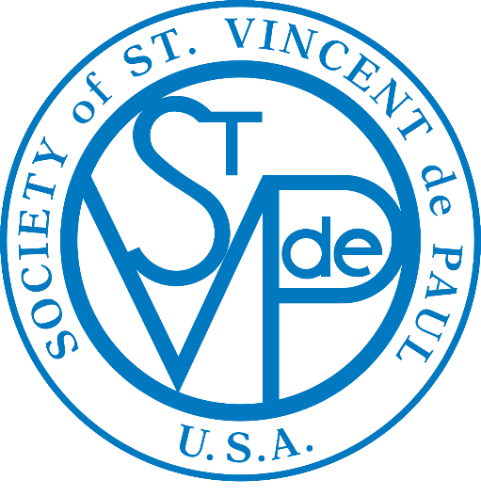

**WEEKLY BULLETIN ANNOUNCEMENTS**

**Liturgical Year B/C**

**4th quarter**

**October—November—December 2024**

# 

## The “Weekly Bulletin Announcements”, based on the Gospel of each Sunday, are suggested for your parish weekly bulletin.

## The action statement can easily be adapted to fit your local needs.

## This is a very effective way for the Society of St. Vincent de Paul to encourage all the members in the parish:

* To have ears to hear the “cries of the poor,”
* To have eyes to “seek and find the forgotten, the suffering or the deprived,” and
* To have hearts that “bring God’s love to the poor” through their generosity and donations.

**It is also very effective to use personal stories about who you have served (not using names) and how you have been able to help them.**

**October 6-Twenty-Seventh Sunday in Ordinary Time:**

In today’s Gospel, Jesus tells his disciples, “Let the children come to me…for the kingdom of God belongs to such as these.”

**This week, please help the Society of St. Vincent de Paul to bring the love and mercy of Jesus to children who are hungry and cold.**

**October 13-Twenty-Eighth Sunday in Ordinary Time:**

In today’s Gospel, Jesus says: “Go, sell what you have, and give to the poor and you will have treasure in heaven; then, come follow me.”

**Have you considered answering the call to help serve the poor by joining the Society of St. Vincent de Paul?**

**October 20-Twenty-Ninth Sunday in Ordinary Time:**

In the Gospel today Jesus tells his disciples: “Anyone among you who aspires to greatness must serve the rest; whoever wants to rank first among you must serve the needs of all.”

**When you give the furniture, household items and clothing you no longer use to the Society of St. Vincent de Paul, you give hope to your neighbors who have nothing.**

**October 27-Thirtieth Sunday in Ordinary Time:**

In this Sunday’s Gospel, Jesus asks Bartimaeus: “What do you want me to do for you?” And he answers, “Master, I want to see.” Let us ask Jesus for the grace to “see” our brothers and sisters who are poor and lonely.

**This month, through your gifts, the Society of St. Vincent de Paul was able to bring God’s love and mercy to families, providing in food, for utility, rent and**

**other bills. God Bless You!**

**November 3-Thirty-First Sunday in Ordinary Time:**

In the Gospel today, Jesus tells us: “You shall love the Lord your God with all your heart, with all your soul, with all your mind, and with all your strength…and you shall love your neighbor as yourself.”

**Through your gift to the Society of St. Vincent de Paul you can show your love for our Lord and your love of your neighbor who is hungry, hopeless, alone and frightened.**

**November 10-Thirty-Second Sunday in Ordinary Time:**

In today’s Gospel Jesus tells us: “I want you to observe that this poor widow contributed more than all the others who donated to the treasury. They gave from their surplus wealth, but she gave from her want, all that she had to live on.”

**Ask yourself “Am I only giving from my surplus wealth?” and then put your gift in the Society of St. Vincent de Paul poor box so that those who are suffering will be able to know God’s love and care.**

**November 17-Thirty-Third Sunday in Ordinary Time:**

The Gospel predicts end times; our challenge though is to live faithfully now. When we live in conformity to the Word, hearing Jesus’ words and living them out, the future holds no fear for us.

**As you place your gift in the Society of St. Vincent de Paul poor box, know that you are hearing the words of Jesus and living them out.**

**November 24-Christ the King:**

Today as we celebrate Christ the King, may we open the door of our heart so wide that we may listen to the voice of Jesus calling us to help build his kingdom here on earth.

**This month, through your gifts, the Society of St. Vincent de Paul was able to bring God’s kingdom of love and mercy to families, providing in food, for utility, rent and other bills. God Bless You!**

**December 1-First Sunday of Advent:**

As we begin Advent we are called to “wait” in joyful anticipation for the grace of Christmas to once again bless our lives. Wherever you live in our parish, there are poor families within walking distance of your home. When in need, they ring the rectory bell. They are, in effect, ringing your doorbell.

**Your gift in the St. Vincent de Paul poor box will help the poor celebrate the grace of God’s love this Christmas.**

**December 8-Second Sunday of Advent:**

In today’s Gospel John the Baptist urges us to “Prepare the way of the Lord,” and this is what Advent is all about. We are called to help prepare the way of the Lord by making the real meaning of Christmas come alive in our own hearts, in our family and to reach out to those in need.

**Is there a family you know who needs assistance? Please call the Society of St. Vincent de Paul so that together we can help the suffering and poor to celebrate Christmas.**

**December 15-Third Sunday of Advent:**

In today’s Gospel John the Baptist says, “Whoever has two cloaks should share with the person who has none. And whoever has food should do likewise…”

**Christmas is a time of love and gift giving…please share your abundance by giving a gift to the Society of St. Vincent de Paul so that those who do not have clothes and food can share in the blessings of Christmas.**

**December 22-Fourth Sunday of Advent:**

Jesus was born during the night of the year when darkness is the longest. The Savior of the world comes for the people in dark places. The real, lasting, and deep joy is that the Light shines there.

**Through your gift to the Society of St. Vincent de Paul, “Light” has shown, bringing real, lasting and deep joy to the hearts of the poor who live in dark places in our streets and neighborhood.**

**December 29-Holy Family:**

Today is the feast of the Holy Family of Jesus, Mary and Joseph, and so we can celebrate that we all belong to the holy family of God which makes us brothers and sisters to each other.

**At Christmas this year, through your gifts, the Society of St. Vincent de Paul was able to bring the joy and hope to our “brothers and sisters” who are poor by assisting families, providing in food, in gifts, and for utility and rent bills. Thank you!**